**Application to make the Gas filling Station easy using CRM (Developer)**

**ABSTRACT:**

The Gas Filling Station CRM Application is a Salesforce-based solution designed to simplify and optimize the operations of gas filling stations. This system integrates Customer Relationship Management (CRM) features to manage customers, suppliers, buyers, and fuel transactions efficiently. The application automates processes such as fuel tracking, billing, reporting, and customer management, thereby improving service quality and operational efficiency.

Customers benefit through transparent records, accurate billing, and better service communication, while station managers gain powerful tools for monitoring supply, nalysing business performance, and ensuring compliance. Built on Salesforce, the solution ensures scalability, role-based access, security, and real-time insights, making gas station operations more reliable and technologically advanced.

**OBJECTIVE:**

The main objective of the Gas Filling Station CRM Application is to digitalize gas filling station operations using Salesforce CRM. Specifically, it aims to:

* **Enhance Customer Experience**
* Maintain detailed buyer/customer records.
* Provide transparency in billing and payments.
* Record vehicle and fuel transaction details.
* **Optimize Store Operations**
* Track suppliers and fuel supplied to stations.
* Monitor fuel usage and availability automatically.
* Reduce manual errors through validations and formula fields.
* **Improve Efficiency and Insights**
* Generate reports and dashboards for fuel estimation and sales analysis.
* Enable decision-making through summarized and real-time data.
* **Ensure Secure Data Access**
* Assign profiles and roles with specific permissions.
* Implement validation rules to maintain data accuracy.

**REQUIREMENT ANALYSIS AND PLANNING**

**Custom Objects:**

Custom objects allow storing data specific to the business. In this project, the following objects are created:

* **Gas Station**: Maintains station information, fuel availability, and usage.
* **Supplier**: Tracks suppliers and the total fuel supplied.
* **Buyer**: Stores customer details and manages purchases.
* **Fuel Details**: Acts as a junction object linking suppliers and gas stations

**Tabs:**

Tabs are used for navigation and record management in Salesforce. Tabs were created for all four objects: Gas Station, Supplier, Buyer, and Fuel Details.

**Lightning App:**

A Lightning App bundles objects, tabs, and tools together for a role-based UI. A Gas Station Lightning App was created to access all four objects in one application.

**Page Layouts:**

Page layouts define how information is displayed on record pages. For example, the Buyer object page layout was divided into:

* **Personal Details** (First Name, Last Name, Customer Name, Phone, Email, Gas Station Name).
* **Vehicle Info** (Fuel Filled, Vehicle Type, Mode of Payment).
* **Receipt Details** (Mode of Payment, Amount Paid).

**Profiles:**

Profiles determine what users can see and do. In this project:

* **Manager Profile** (full access to all objects).
* **Sales Executive Profile** (limited access).
* **Sales Person Profile** (basic access).

**Roles and Hierarchy:**

Roles control record visibility in Salesforce. A hierarchy was created as:

* Manager
* Sales Executive
* Sales Person

**Users:**

Users represent individuals logging into Salesforce. Example users were created for Manager, Sales Executive, and Sales Person with assigned profiles and roles.

**Project Implementation steps**

1. **Setting up salesforce org:**

Go to <https://developer.salesforce.com/signup> , On the sign up form, enter the following details:

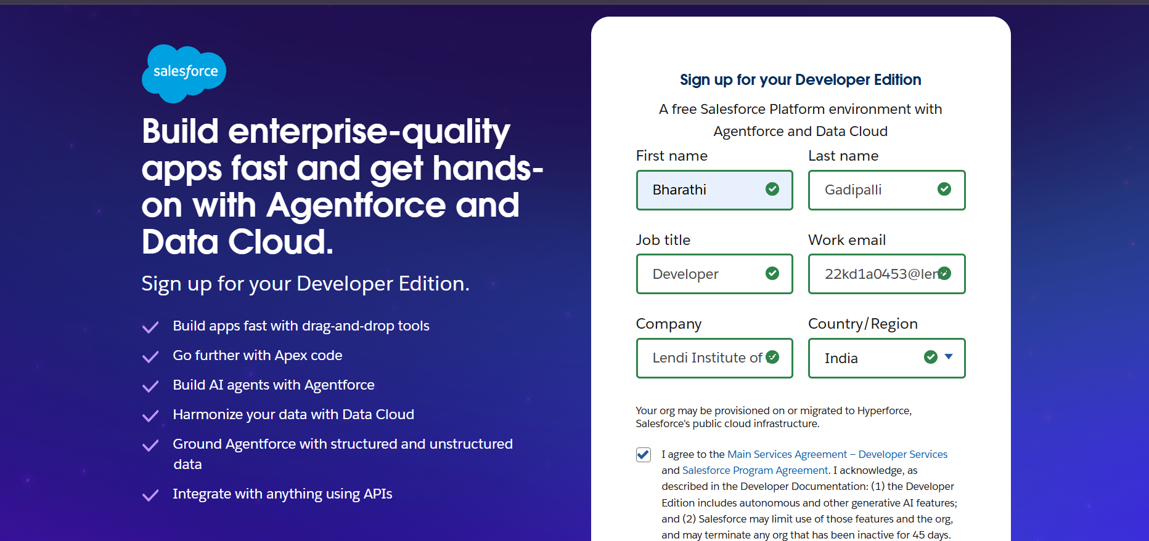

1. **After setting up reset the password by using the mail received to your project.**

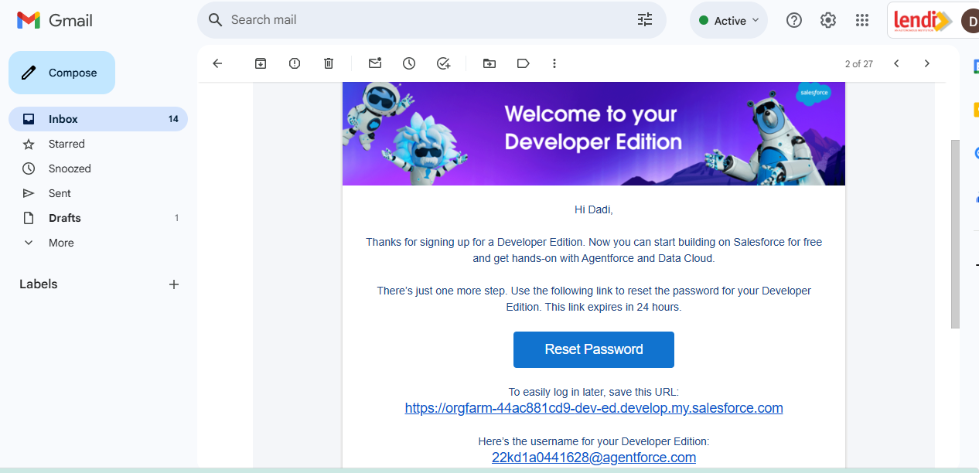

**3. Now we need to create custom objects in setup page. Steps to create custom object is:**

Go to gear icon shown on the sales tabs. Click on the gear icon and go to setup

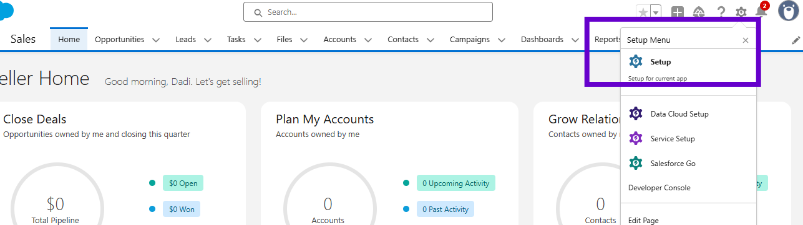

Now a setup page is opened. There we can see few tabs. Select object manager tab. Click on create shown on right corner. Select custom object.

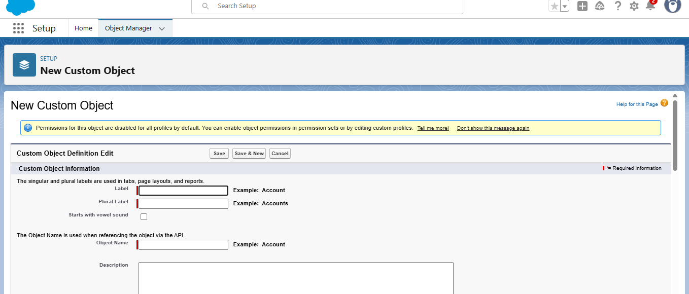

Now we need to fill the details provided such as label, plural name. Object name is auto filled. Create four custom objects:

1. Buyer__ c : Stores customer details and manages their fuel purchases.
2. Fuel_ details__ c: Records fuel transactions linking buyers, suppliers, and gas stations.
3. Gas_ Station__ c: Maintains gas station information, fuel availability, and usage.
4. Supplier__ c: Tracks suppliers and the total fuel supplied to stations.

**4.Custom tabs:**

A tab is like a user interface that is used to build records for objects and to view the records in the objects.

For creating custom tab go to setup page, search tabs in quick find box. Click on new. Select the object you want to custom tabs now give the tab style click on next ,next and save and new.

Repeat the same process and crease four tags to four objects named as: Gas station, Buyer, Fuel details, Supplier .You can select tab style as your wish.

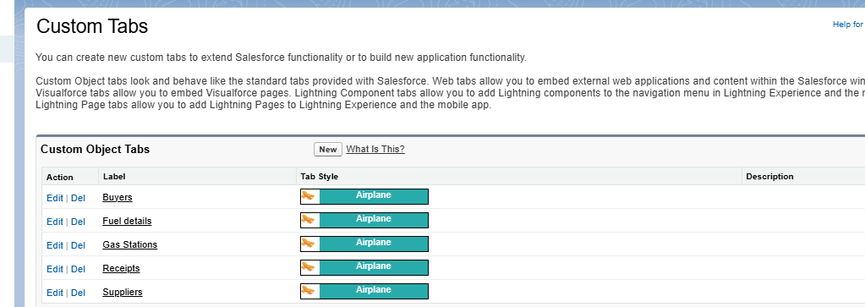

1. **Create Lightning App:**

Lightning apps let you brand your apps with a custom colour and logo. You can even include a utility bar and Lightning page tabs in your Lightning app. Members of your org can work more efficiently by easily switching between apps.

**To create a lightning app page:**

Go to setup page. Search for “app manager” in quick find then select “app manager” and click on new lightning App.

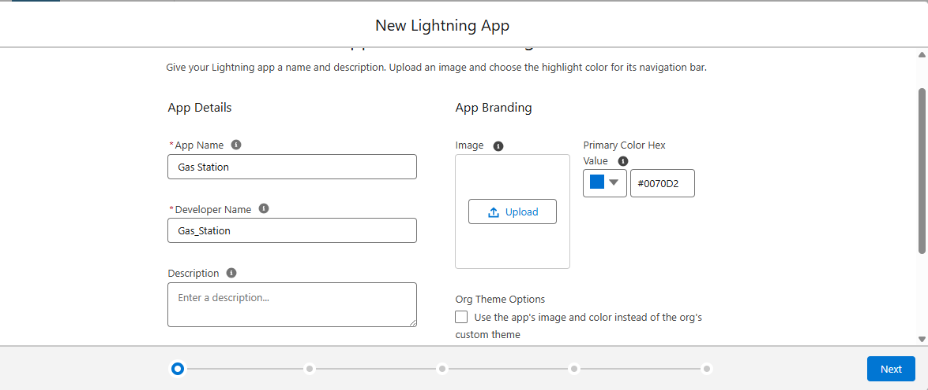

Give the details as above. Click on next. Keeping everything as Default until you visit To Add Navigation items.

In Available Items search for each object and click on the arrow as shown.

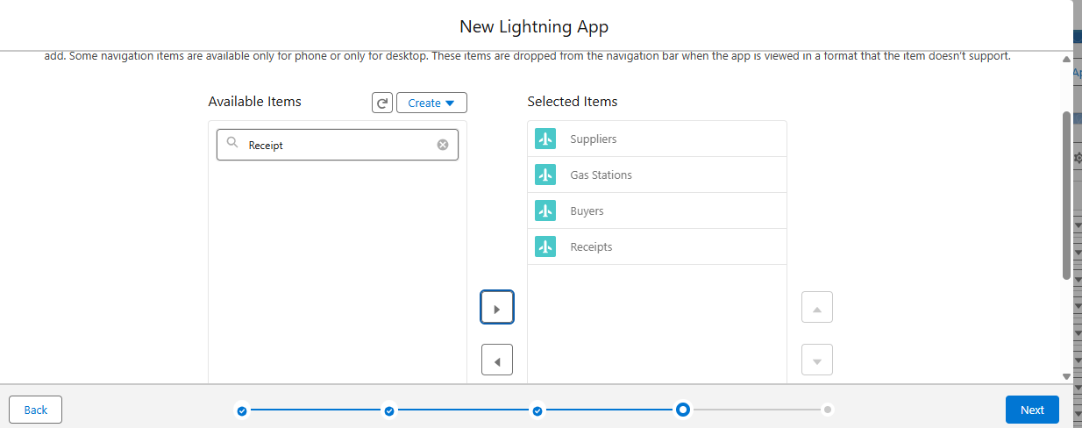

In User Profiles, Search for System Administrator, click on Save & Finish. Now lightning app is ready.

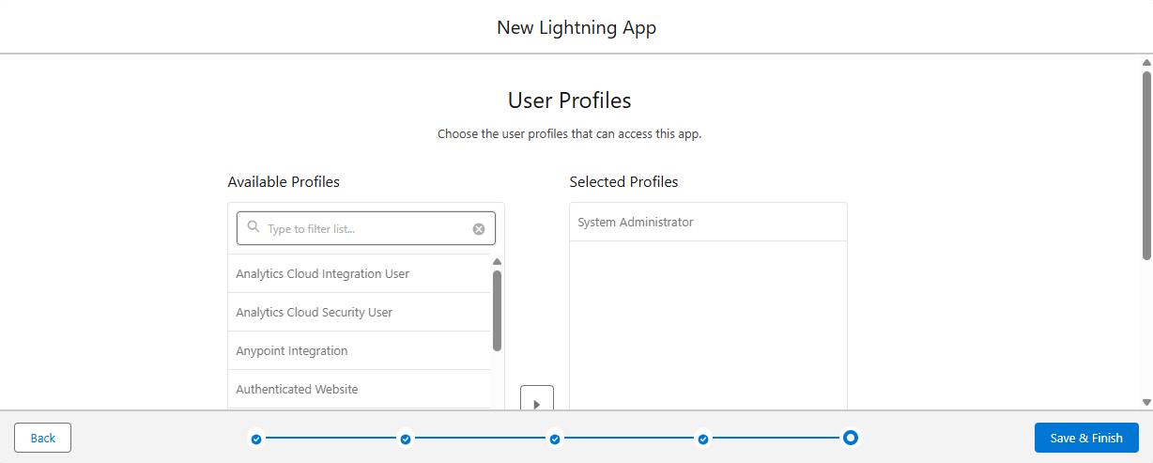

1. **Creating fields**

**Buyer__ c:** First Name, Last Name, Customer Name (Formula), Phone Number, Email, Vehicle Type (Picklist), Fuel Filled in Vehicle, Mode of Payment (Picklist), Amount Paid (Formula).We need to create all these fields first.

**Creating junction object**: Open fuel details objects from object manager and create a field with master detailed relationship data type. Give the field label as Supplier click on next, next and save.

**Creating Master Detailed Relationship**:

Master-detail relationship is a type of relationship between two objects where the master object controls certain behaviours and settings of the detail object.

To create master detail relationship, Go to the setup page now click on object manager from drop down click edit for Buyer object.

1. Click on fields & relationship? click on New.
2. Select “Master-Detail relationship” as data type and click Next.

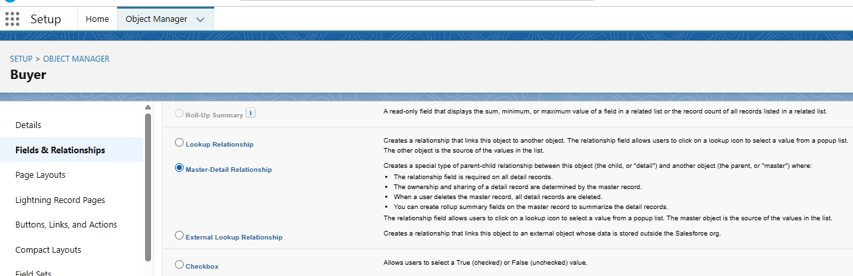

1. Select the related object “Gas station”.
2. Give Field Label as “Gas Station name” and click Next, Next ,Next ,Save.

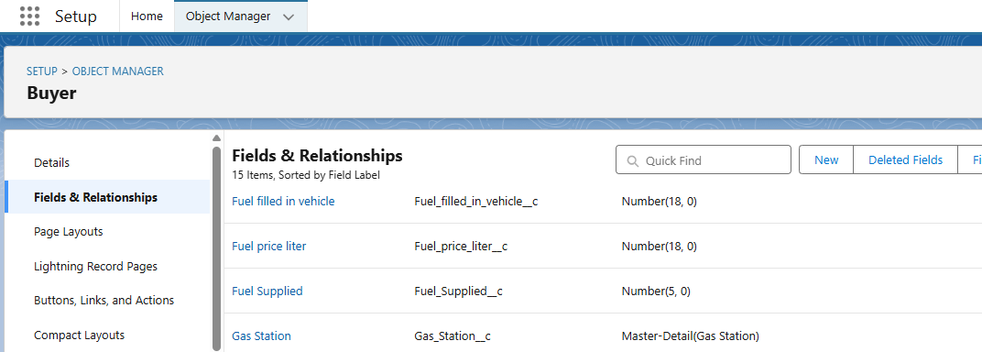

**Creating roll up summary:**

Go to setup, then click on object manager select supplier object. Go to Fields and relationship choose “Roll up summary” data type.

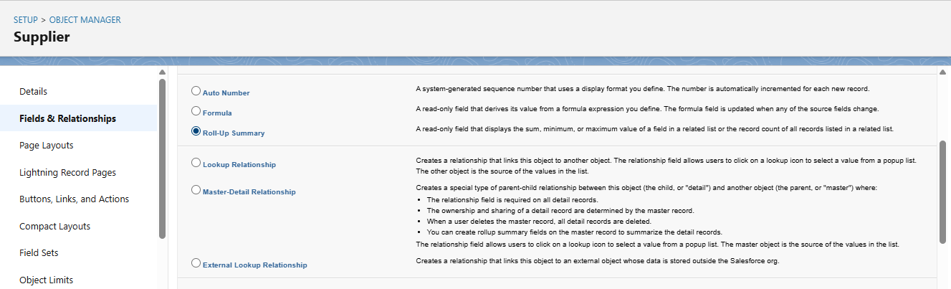

Click next. Give the Field label as “Sum of Fuel supplied” the field name will be auto generated. Click next.

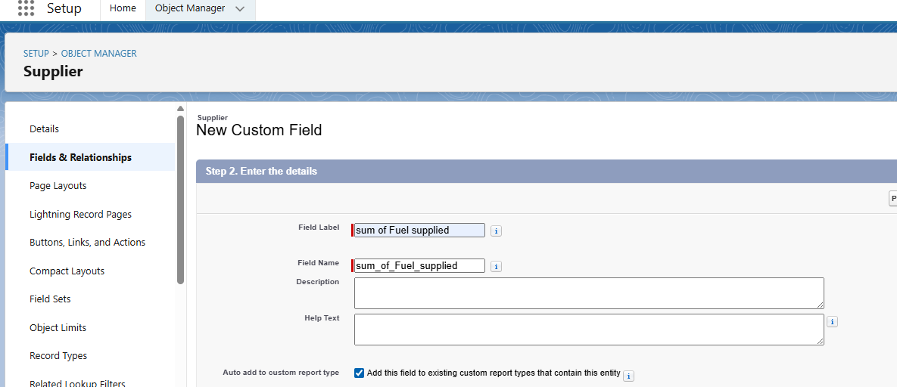

Select the summarized object as “Fuel details” then Select the Rollup type as “sum”. Select the field to aggregate as “fuel supplied”, and click Next , Next , Save.

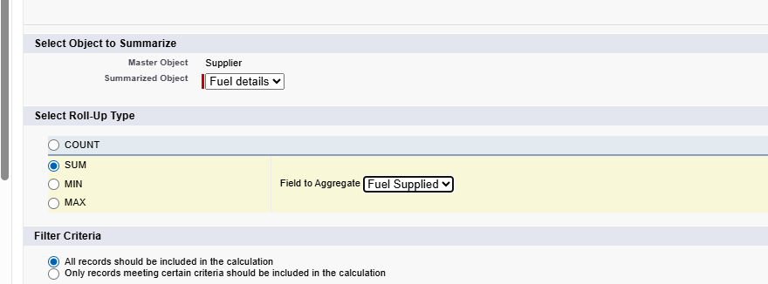

Do the same process for Buyer object, set the field label as “Fuel used” and summarized object as “Buyer” and roll type as “Sum” and field aggregate as “Fuel filled in vehicle”. Click next, next and save.

1. **Creating page layout**

Go to Setup page then Click on Object manager Select Buyer object. From drop down select Page layout. Click on new. Select the existing page layout, and give the page layout name as “customer layout”, and click save.

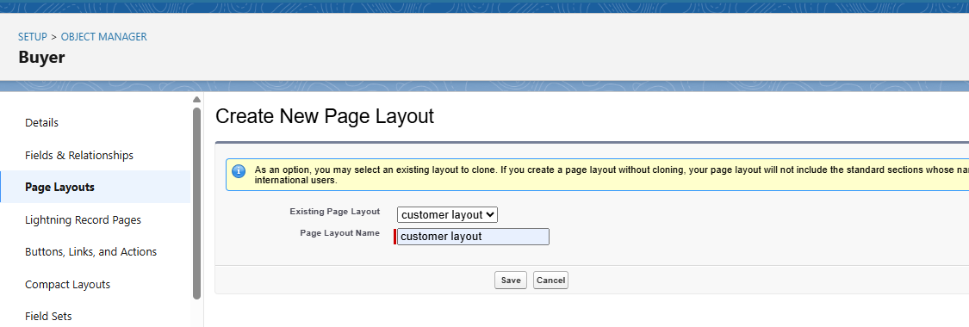

Next set Section Name as Personal details. Click ok.

Now drag the fields First name, last name, customer name, phone number, email, Gas station name into it.

Create another two sections and name it as vehicle info and Receipt details. Drag fuel filled in vehicle, vehicle type fields into vehicle info section.

Drag Mode of payment, Amount paid into receipt details section. Click save.

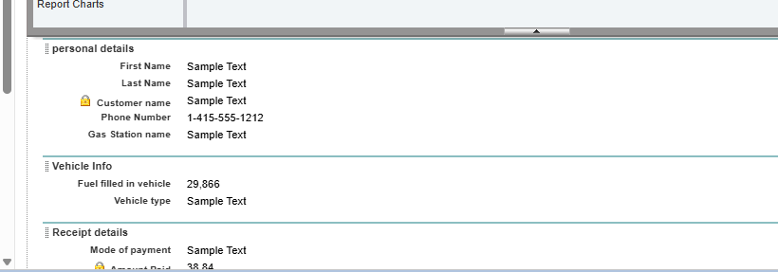

1. **Create Profiles**

Profiles ensure proper access control and define what data/actions each role can perform. They also help in maintaining security and restricting unnecessary access.

* Cloned an existing profile Standard User for manager and Salesforce Platform User for remaining.
* Give a Profile Name (Manager, Sales Executive, Sales Person) and click Save.
* Select standard user and click on clone. Give profile name as Manager.

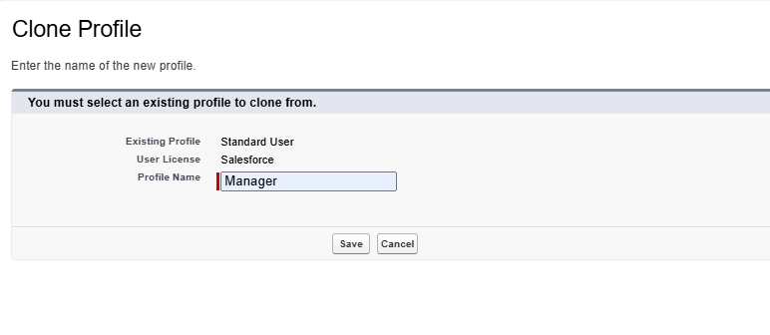Click save. Click edit. Select the Custom App settings as default for the Gas station.

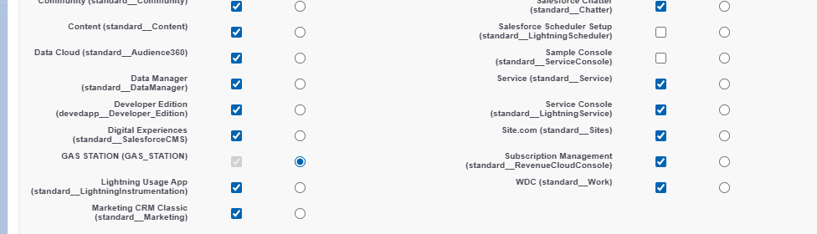

Now we need to give object permissions scroll down to object permissions and give access permissions for Buyers, Fuel details, gas station and supplier’s objects as shown below.

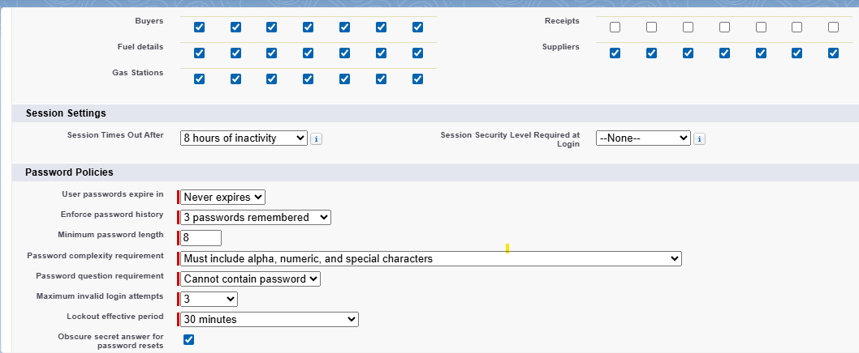

Click Save.

1. **Creating roles and hierarchy**

**Creating manager role:**

Go to setup page. In quick find box, search for roles. Click on setup roles and click on expand all.

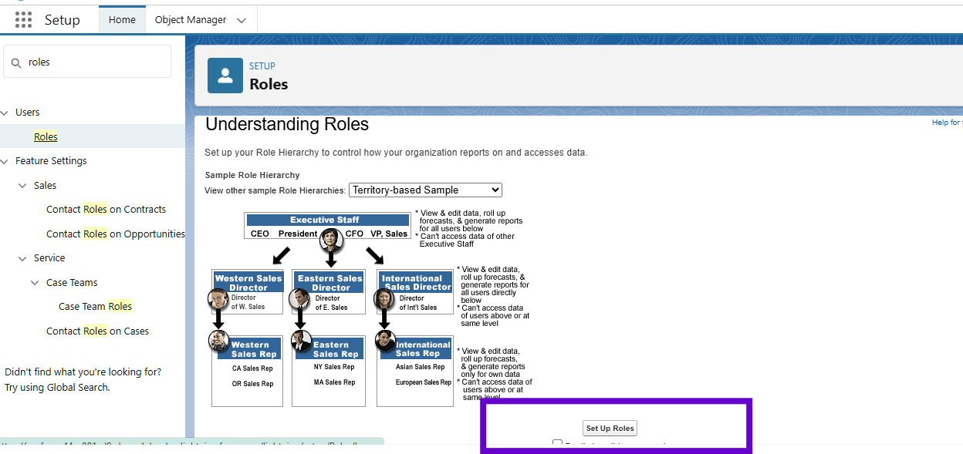

Now select CEO. Click on add new role. Give Label as “Manager” and Role name gets auto populated. Then click on Save.

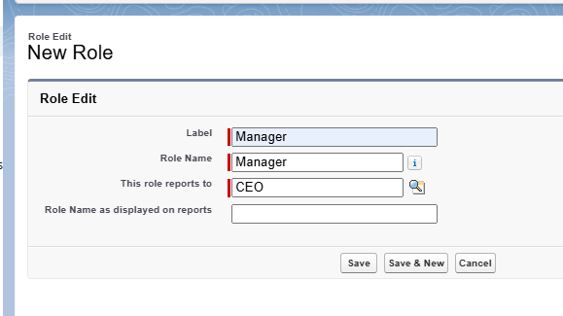  
Click on save. Same as above process create sales executive under manager.

Create another role Sales person under Sales executive by following above steps.

**10.** **Creating users**

Go to setup then type users in quick find box then select users then click New user.

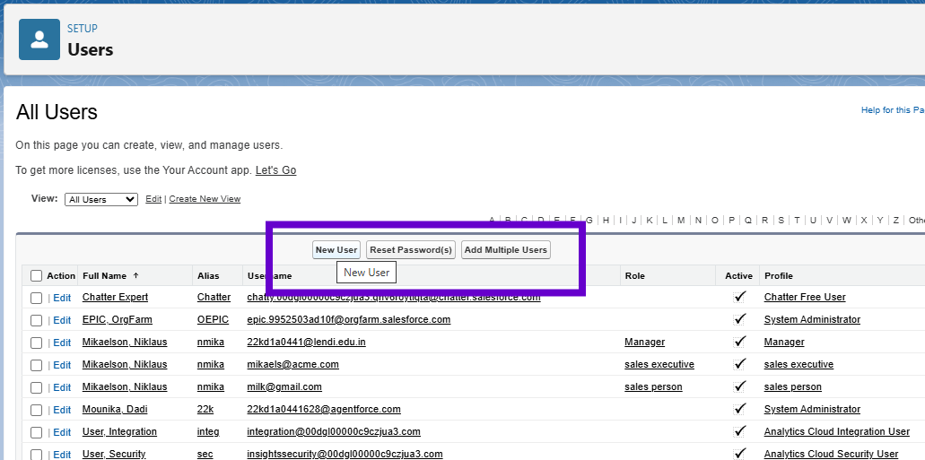

Fill the details:

* First Name : Niklaus
* Last Name : Mikaelson
* Alias : Give a Alias Name
* Email id : Give your Personal Email id
* Username : Username should be in this form: text@ text .text
* Nick Name : Give a Nickname
* Role : Manager
* User licence : Salesforce
* Profiles : Manager
  + Click on sale after filling all details.

**Creating another users**

1. Follow the same steps from above activity and create another user using

Role      :  sales executive

User licence  :  Salesforce Platform

Profile           :  sales executive

1. Repeat the steps and create another user using

Role                  : sales person

User licence      : Salesforce Platform

Profile               : sales person

1. **Permission sets**

Go to setup then type “permission sets” in quick search then select permission sets new.

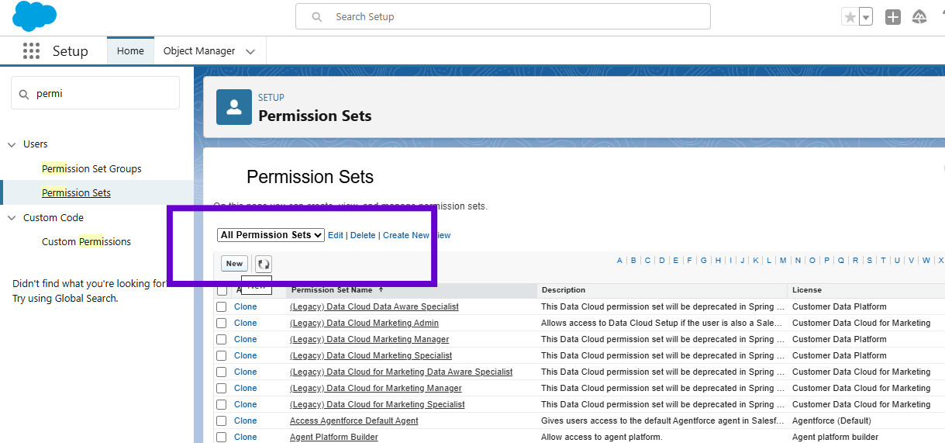

Enter the label name as “P1”, API will be auto populated and save.

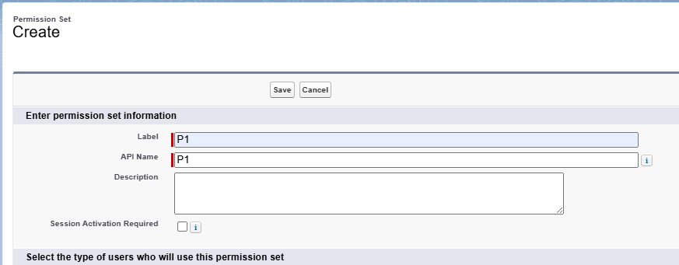

Click on save. Under Apps Select object settings.

Click on Fuel details object and click on Edit then under object permission check for read and create.

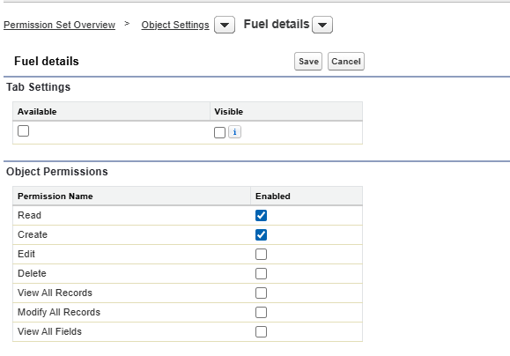

Click on add assignments.

**12. Create OWD Setting**

Go to setup. Click on sharing settings.

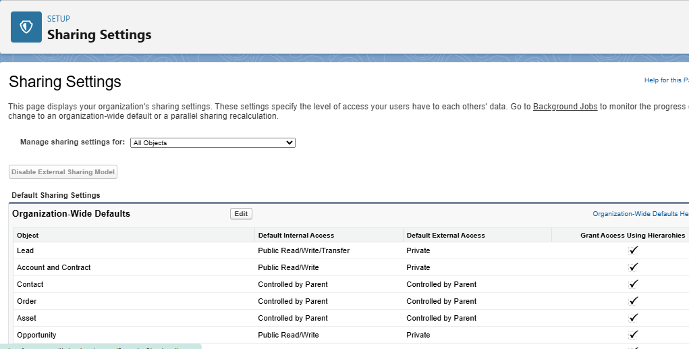

Click on edit. Scroll down, change the default internal access to “public read-only” for Gas station and Supplier object.

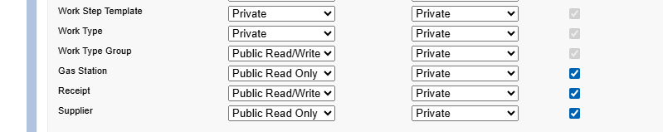

Click save.

1. **User adoption**

Click on app launcher, Click Gas station app. Click on “fuel details tab”.

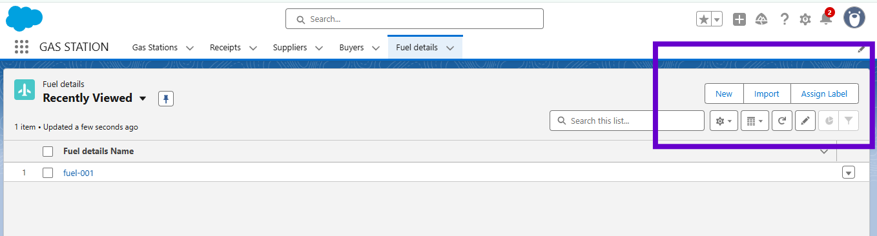

Click on new.

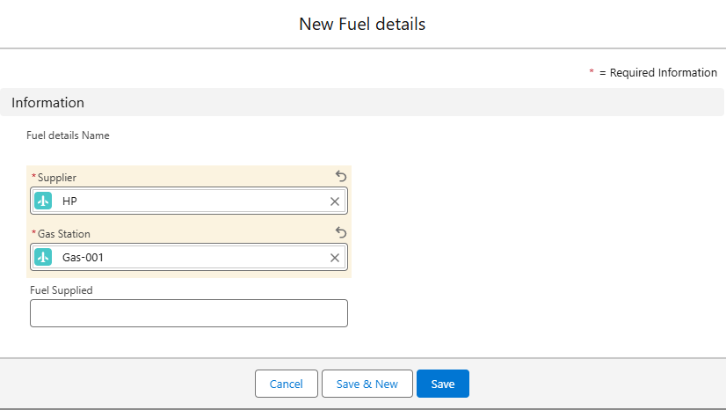

Click on save.

**View a record:**

To create a record in junction object follow these steps

1. Click on the app launcher locate at left side of the screen.
2. Search for “Gas station” and click on it.
3. Click on “fuel details tab”.
4. Click on the records that are already created.

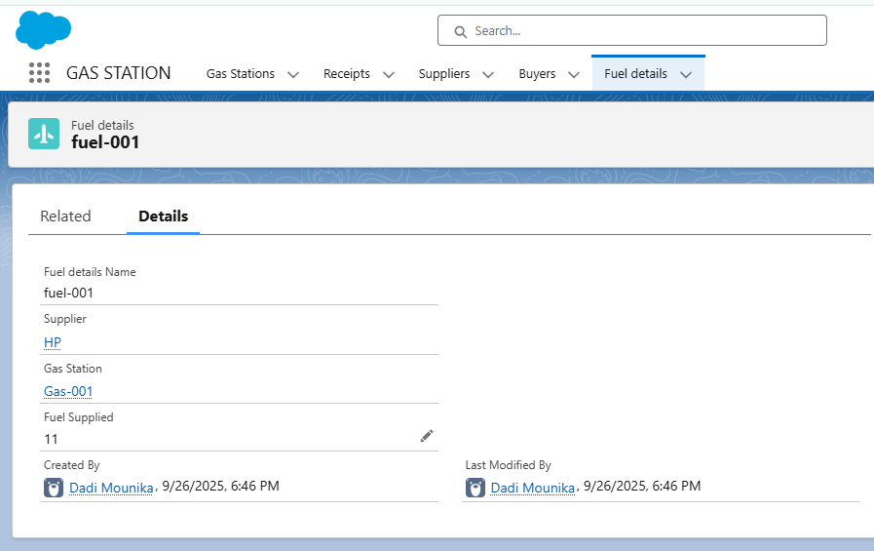

**Delete records:**

To create a record in junction object follow these steps

1. Click on the app launcher locate at left side of the screen.
2. Search for “Gas station” and click on it.
3. Click on “fuel details tab”.
4. Click on Arrow at right hand side on that Particular record.
5. Click delete and delete again.

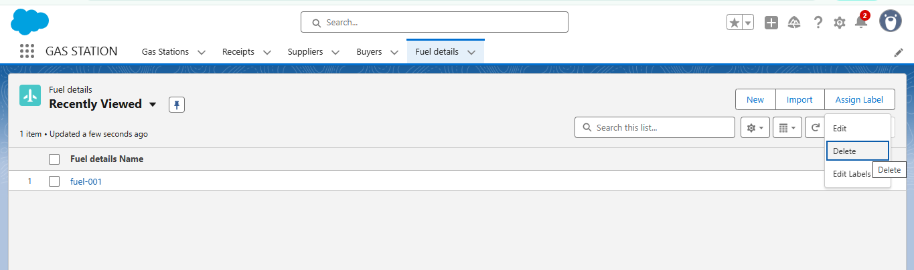

**13. Reports**

**Create a report folder:**

Reports are used to analyse and display Salesforce data in a structured format.

* In this project, custom reports were created to track fuel usage, customer activity, and sales for better decision-making.

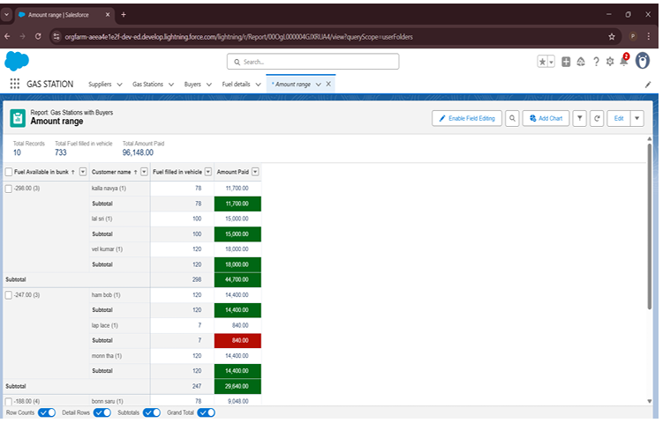

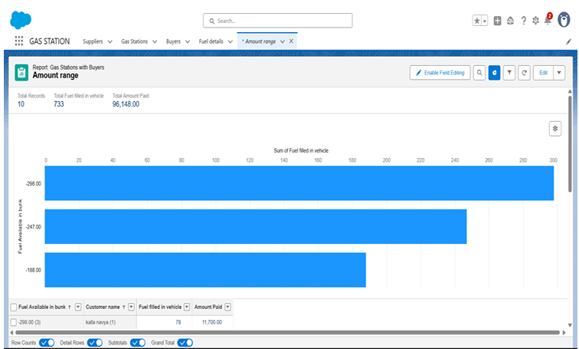

**14. Dashboards**

**Creating dashboard folder:**

Click on the app launcher and search for dashboard. Click on dashboard tab. Click new folder, give the folder label as “Amount estimation dashboard”.

Folder unique name will be auto populated. Click save.

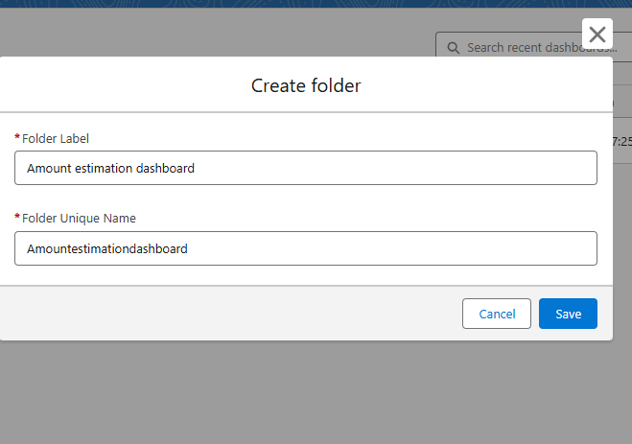

**Creating dashboard:**

Click on the app launcher and search for dashboard. Click on dashboard tab. Choose new dashboard.

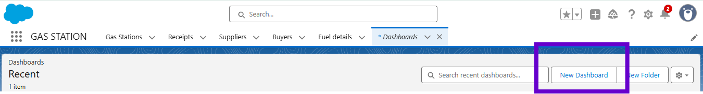

Fill the details as given below.

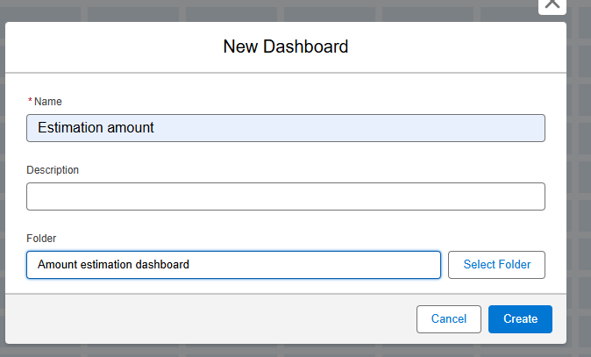  
 Click on create. Now click on add widget.

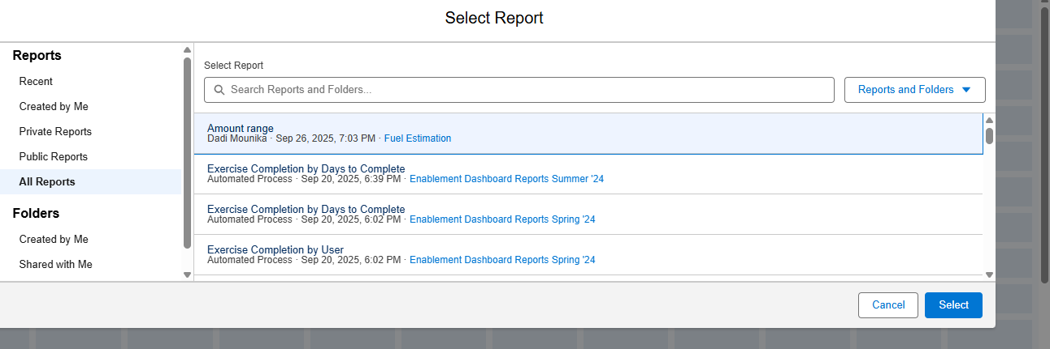

Select All reports and select Amount range and click select. Click on save and done. A Preview is opened.

**15. Flows**

Go to setup search for flows in Quick find box. Select the new flow, Select record triggered flow.

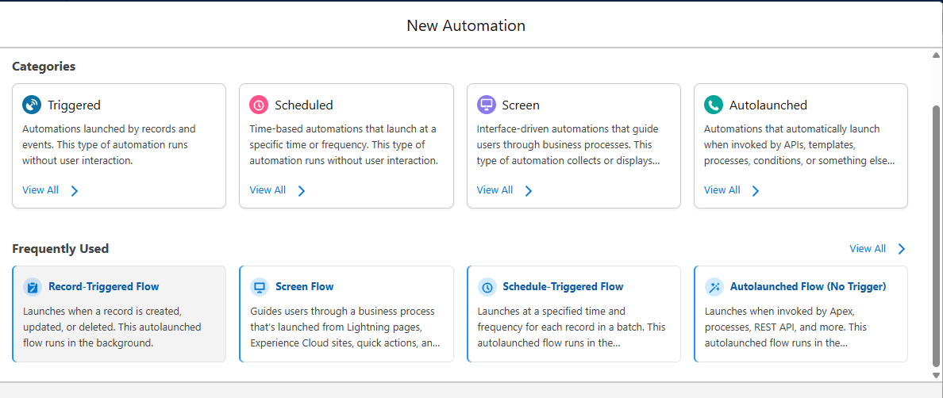

Select the Object as a “buyer” in the Drop down list .Select the Trigger Flow when: “A record is Created or Updated” .Select the Optimize the flow for:

“Actions and Related Records” and Click on Done.

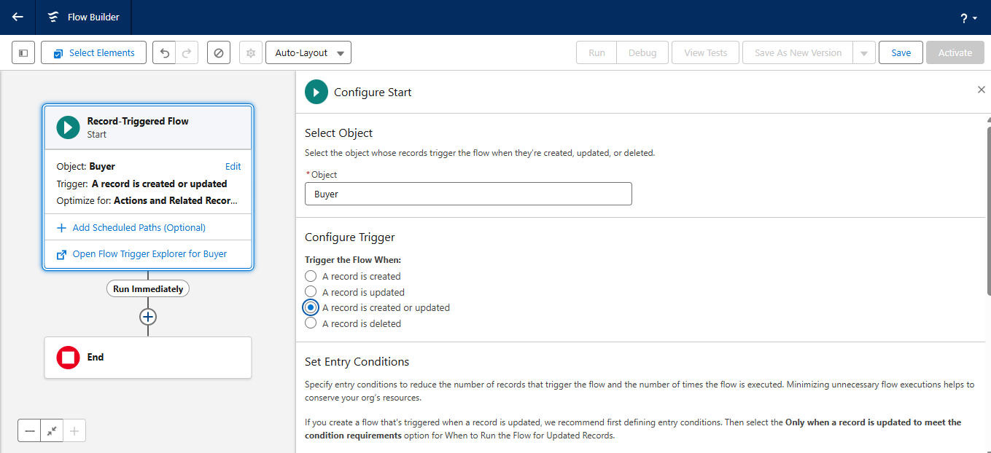

change the mode form Auto-layout to free-form. Add new resource as text template.

Drag the action element give the details as shown

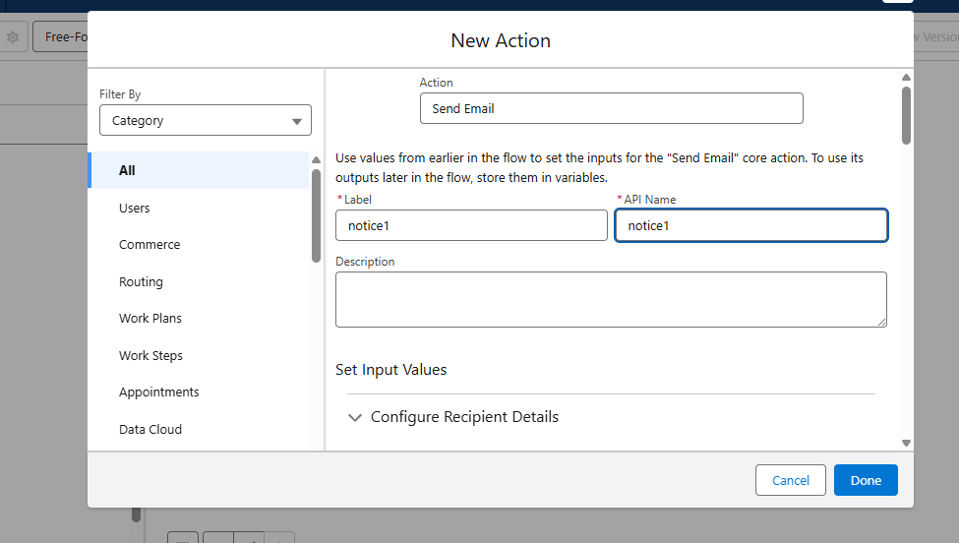

Connect the flow and action element.

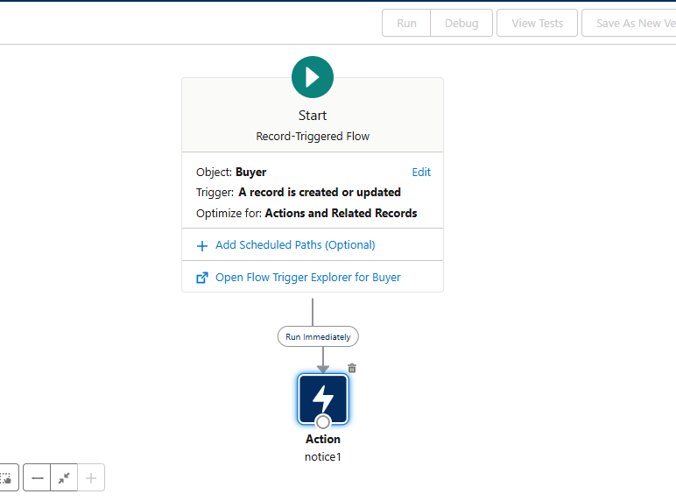

After filling the details save the flow by giving flow label and activate the flow.

**16. Apex trigger:**

1. Login to the respective trailhead account and navigate to the gear icon in the top right corner.
2. Click on the Developer console. Now you will see a new console window.
3. In the toolbar, you can see FILE. Click on it and navigate to new and create New apex class.
4. Name the class as “FuelRecordHandler”.

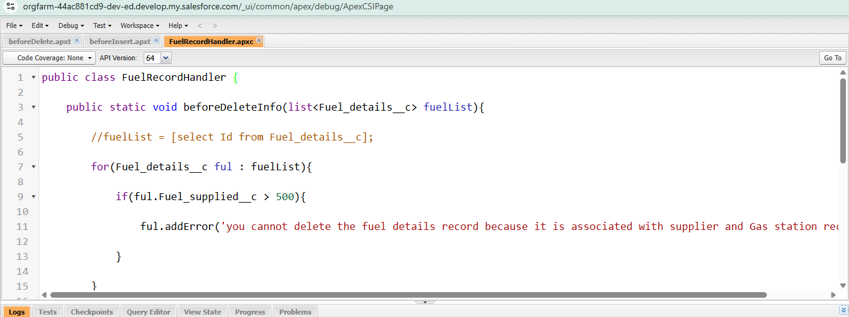

**Create trigger:**

**Handler for the Fuel details Object**

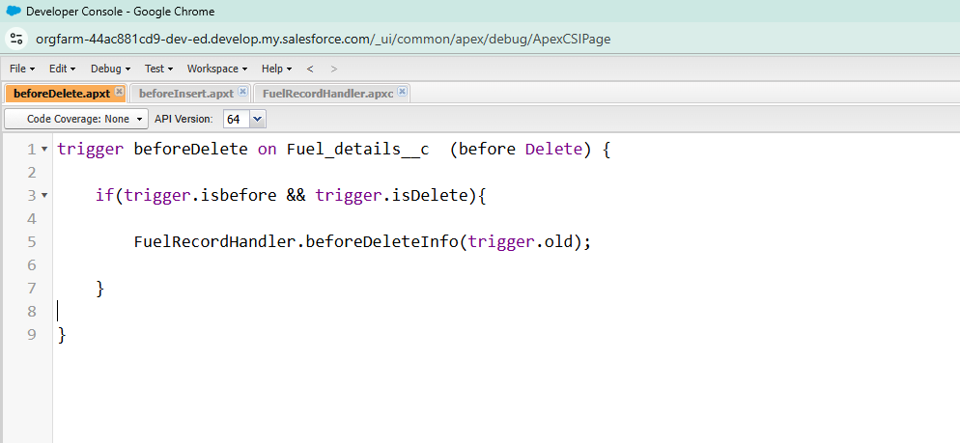

**Handler for the Gas Station Object:**

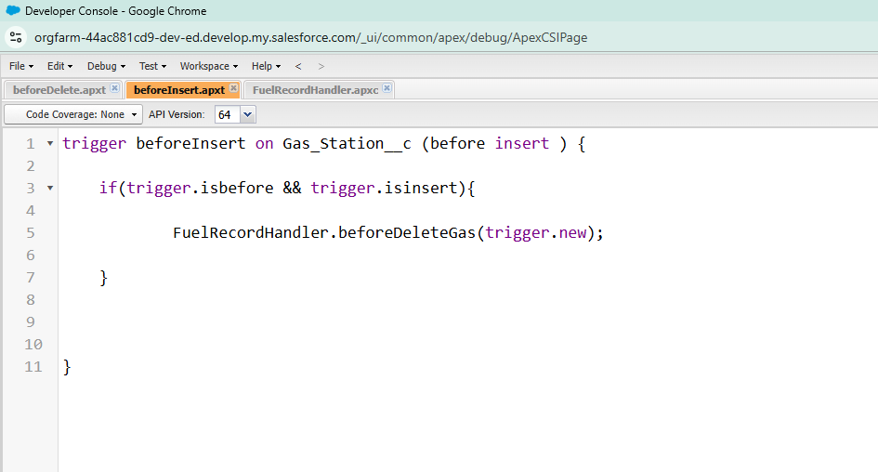

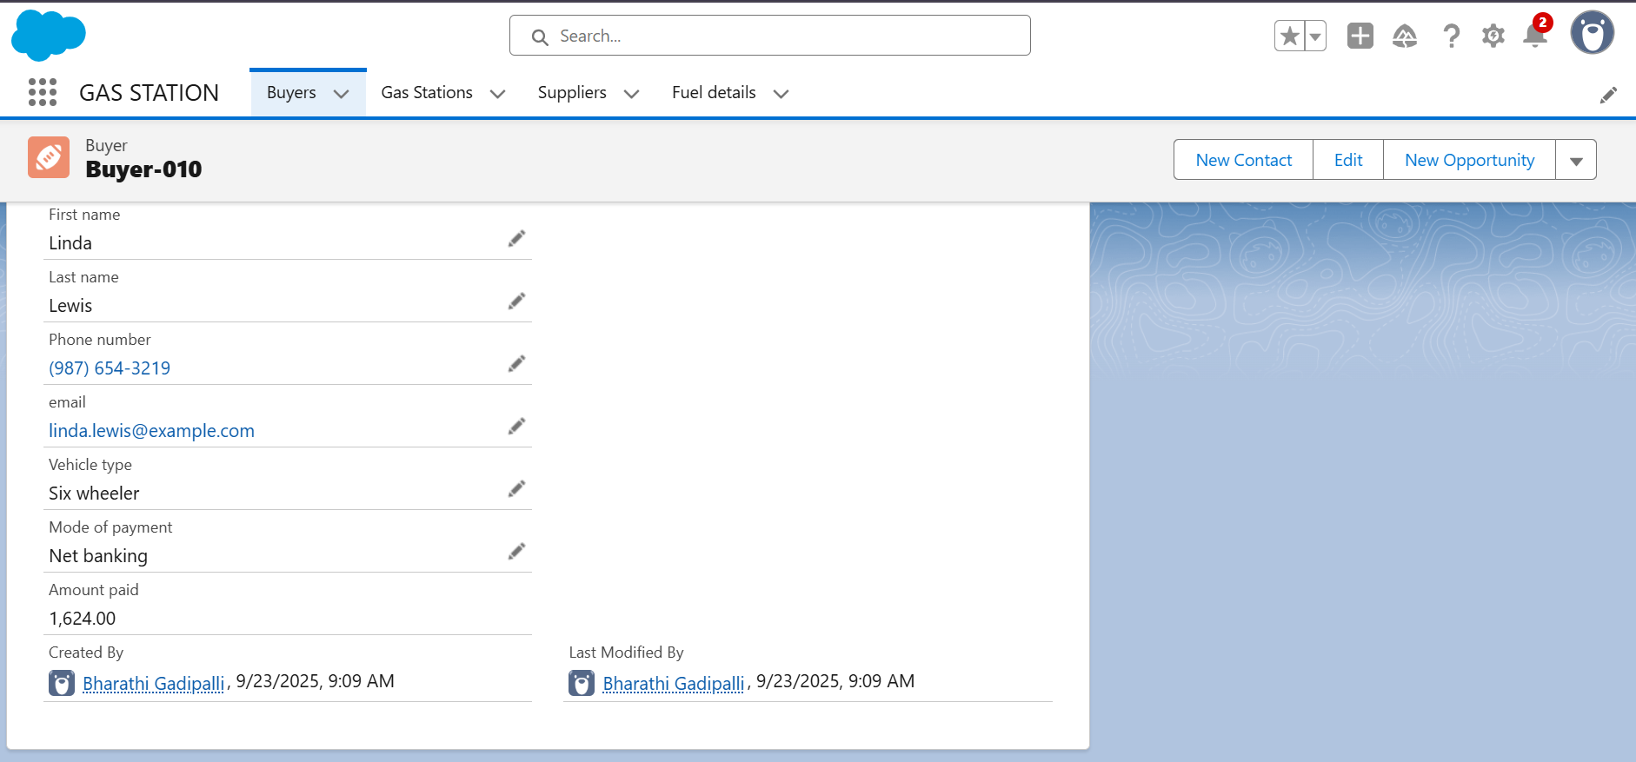

**Conclusion:**

The Gas Filling Store CRM Application successfully addresses the critical challenges faced by gas filling stations through a modern, digital solution. By integrating core CRM functionalities such as customer management, order processing, delivery tracking, inventory control, and automated communication, the application enhances both operational efficiency and customer satisfaction.

This system simplifies the gas refill process for customers, enabling them to book, pay, and track their orders with ease. For store owners and delivery staff, the platform provides a centralized dashboard to manage stock levels, assign deliveries, and monitor business performance in real time.

Furthermore, by leveraging features such as notifications, analytics, and user role management, the application ensures better decision-making, transparency, and security. The use of cloud-based technologies and scalable architecture allows for future expansion and integration with more advanced features like IoT and AI.

In conclusion, the project delivers a robust, user-friendly, and scalable CRM solution tailored to the specific needs of the gas distribution industry, making operations smarter, faster, and more reliable.